**Java Project Report**

**on**

**PB : GO**

**Submitted by**

**Kitipat Teachasupinnun 5930041921**

**Ravipas Plitnonkiat 5930430321**

**Subject**

**Course Programming Methodology Semester 1**

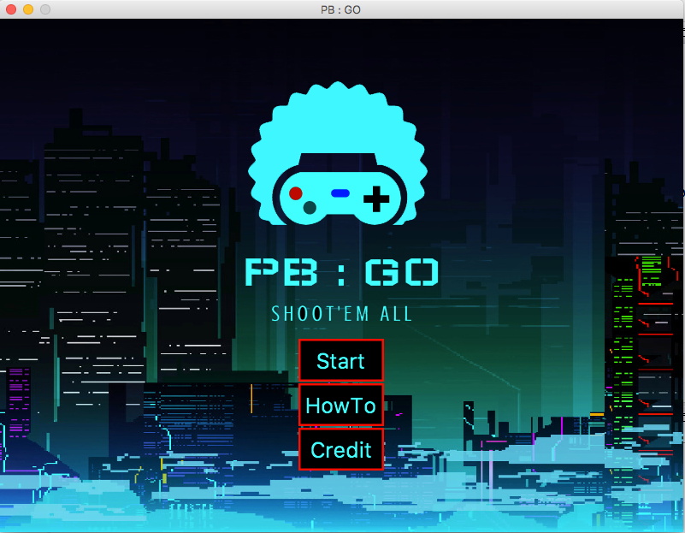

**when start the program you will see mainmenu that have 3 button to click**

**When you click HowTo**

* **You will go to How to play screen that introduce you to know how to control your character.**
* **In this game need 2 player to play together so we have 2 page of Howto to teach you how to control each player character.**

**How to play Player 1**

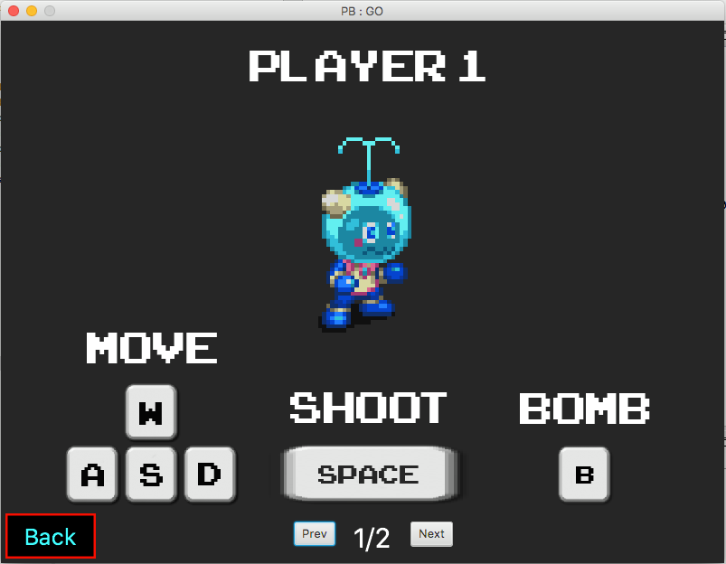

**your can control movement of player1 character by**

**- press A to go left**

**- press W to go up**

**- press S to go down**

**- press D to go right**

**your can command player1 to shoot by**

**- press SPACE BAR**

**your can command player1 to throw bomb by**

**-press B**

**How to play Player 2**

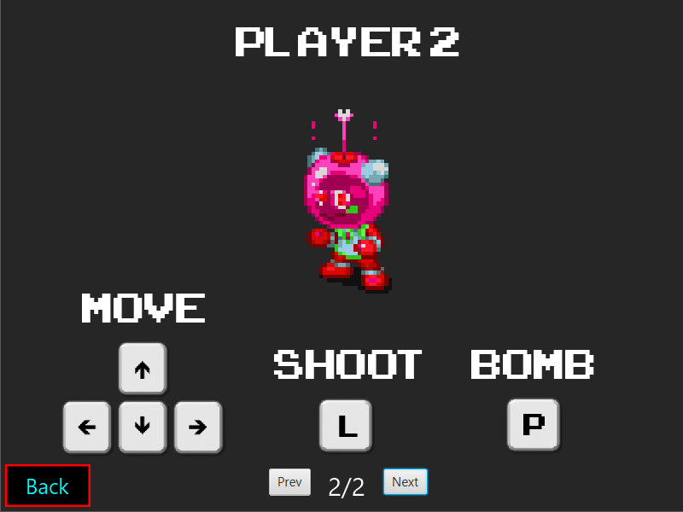

**your can control movement of player1 character by**

**- press ← to go left**

**- press ↑ to go up**

**- press ↓ to go down**

**- press → to go right**

**your can command player1 to shoot by**

**- press L**

**your can command player1 to throw bomb by**

**-press P**

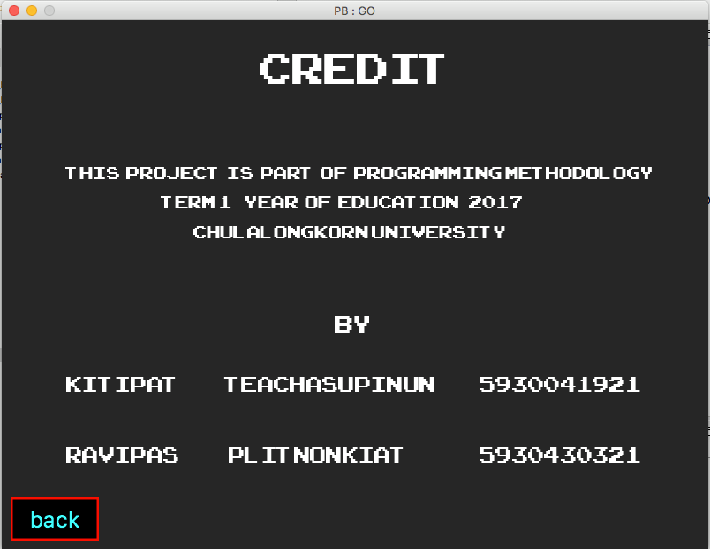

**When you click Credit**

* **You will go to How to credit screen that show credit.**

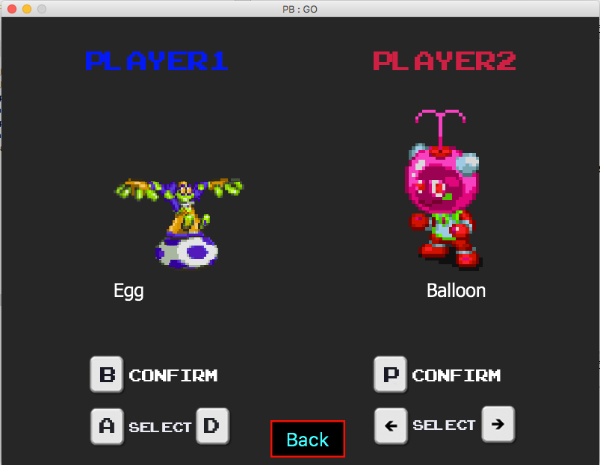

**When you click Start**

* **You will go to How to CharacterSelect screen that let you choose your own character .**
* **Left side is for player 1 to choose character.**
* **right side id for player 2 to choose character.**
* **when you choose finish press your own confirm button to confirm your character.**
* **when two player click confirm go to gameScreen.**

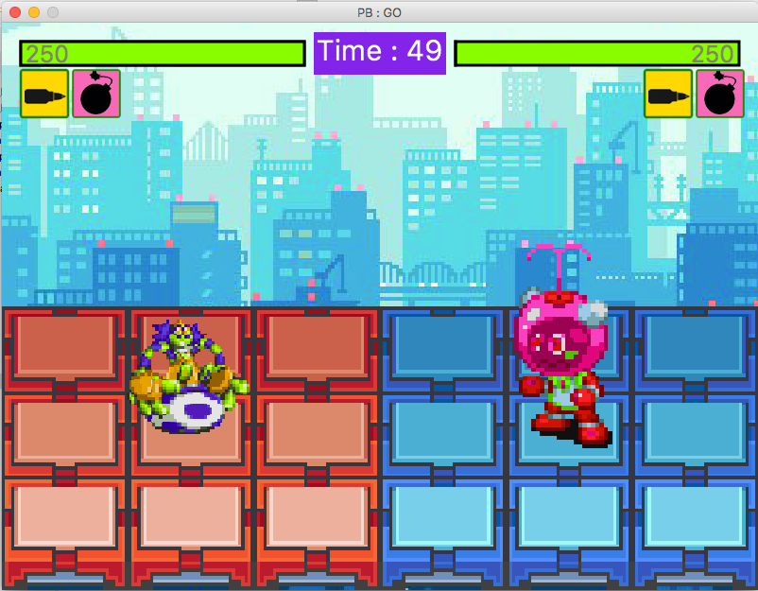

**GameScreen**

**-In this game we separate two player in other side.**

**-player 1 is left.**

**-player 2 is right.**

**-Goal of this game is you must shoot other player to reduce their health to 0 and you will win!!**

**-but if health of each other is equal the match result is draw.**

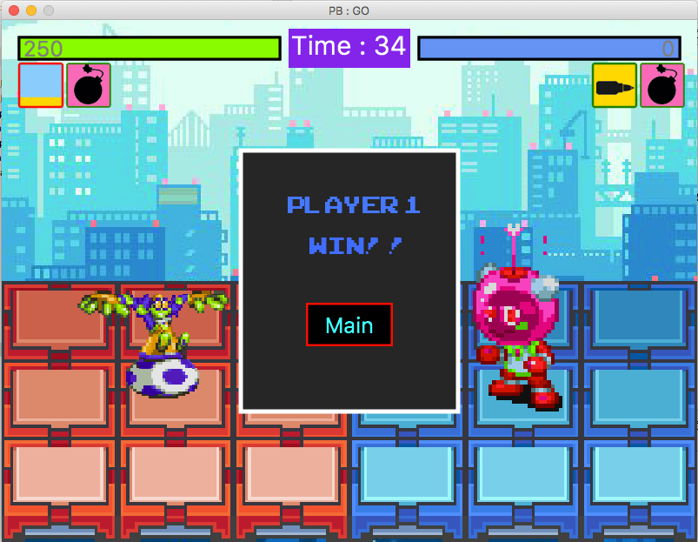

**-when the game end .**

**-at the middle of gamescreen will show match result and you can go back to mainmenu and play again!!**

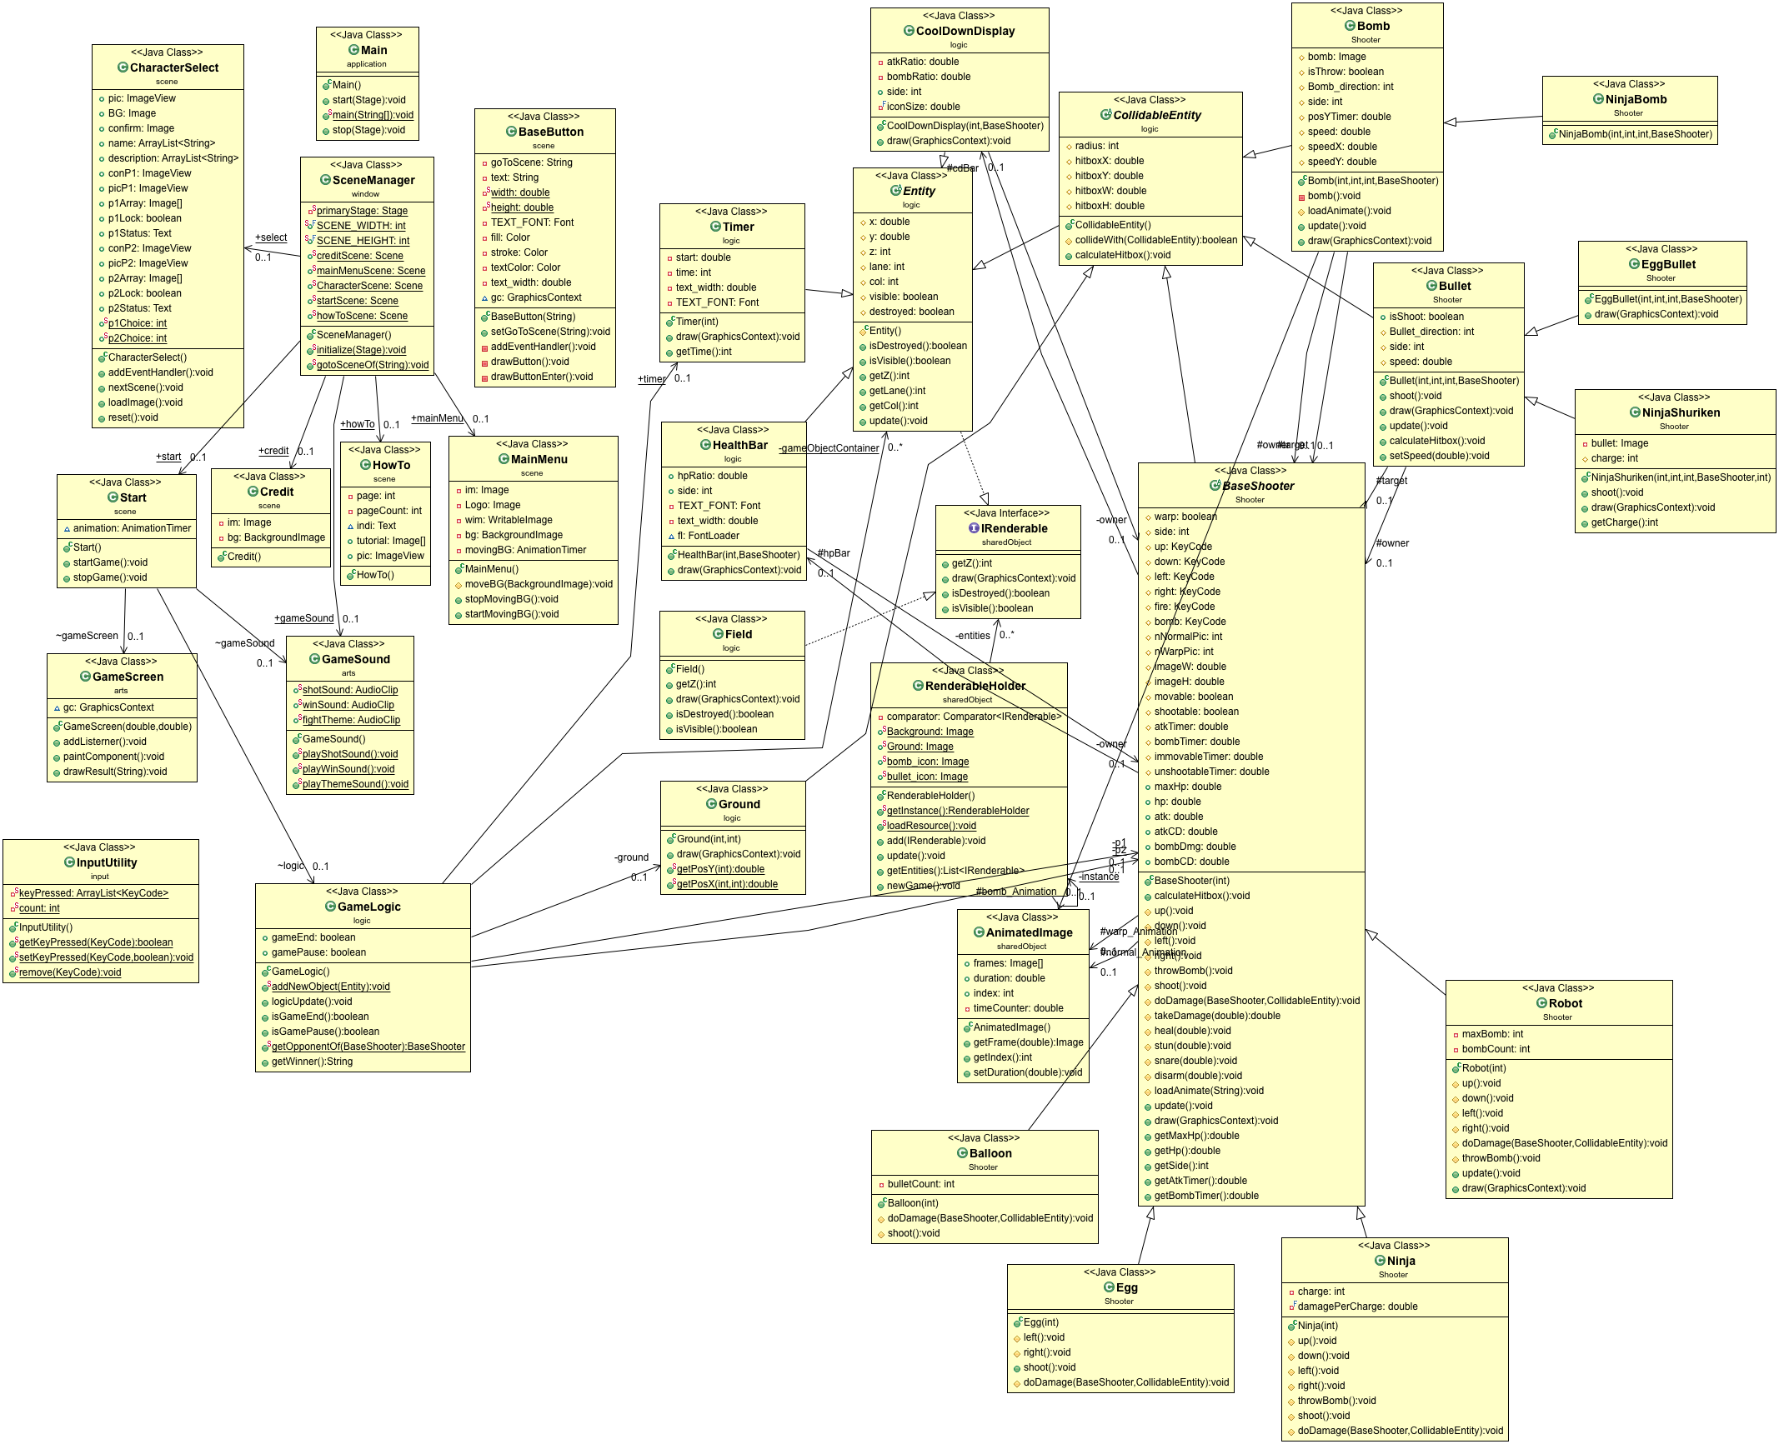

**An UML Diagram of Project.**

**Class Detail :**

**2.1 Package application**

2.1.1 Class main

2.1.1.1 Method

|  |  |
| --- | --- |
| Void start | The main entry point for the JavaFX applications. |
| Void main | An entry point of the application |
| Void stop(stage primaryStage) | This method are going to execute before JavaFX application terminates. |

**2.2 Package arts**

2.2.1 Class GameScreen extends Canvas

2.2.1.1 Field

|  |  |
| --- | --- |
| GraphicsContext gc | A GraphicsContext . |

2.2.1.2 Constructor

|  |  |
| --- | --- |
| GameScreen(double,double) | Initialize GameScreen. |

2.2.1.3 Method

|  |  |
| --- | --- |
| Void addListerner() | Addlisterner to receive key event. |
| Void paintComponent() | This method is used to draw draw all component in IRenderable entity. |
| Void drawResult(String winner) | draw result of game match   * if don’t have any winner match result should be draw. * else draw a result that which player is a winner. |

2.2.2 Class GameSound

2.2.1.1 Field

|  |  |
| --- | --- |
| AudioClip shotSound | AudioClip when you shoot. |
| AudioClip winSound | AudioClip when you win. |
| AudioClip fightTheme | AudioClip when you fighting. |

2.2.1.2 Constructor

|  |  |
| --- | --- |
| GameSound() | · Initialize shotSound.  · Initialize winSound.  · Initialize fightTheme. |

2.2.1.3 Method

|  |  |
| --- | --- |
| Void playShotSound () | play Shot bullet sound. |
| Void playWinSound() | play sound when the game end. |
| Void playThemeSound() | play theme sound when playing game. |

**2.3 Package input**

2.2.1 Class InputUtility

2.2.1.1 Field

|  |  |
| --- | --- |
| ArrayList<KeyCode> keyPressed | ArrayList that keep key that have been pressed |

2.2.1.3 Method

|  |  |
| --- | --- |
| Boolean getKeyPressed(KeyCode keycode) | get the key that you have presses |
| void setKeyPressed(KeyCode keycode,boolean pressed) | set the key that you have pressed |
| void remove(KeyCode keycode) | remove the key in keyPressed |

**2.4 Package logic**

2.2.1 Class CollidableEntity

2.2.1.1 Field

|  |  |
| --- | --- |
| double hitboxX | X position of hitbox |
| double hitboxY | Y position of hitbox |
| double hitboxW | hitbox width |
| double hitboxH | hitbox height |

2.2.1.3 Method

|  |  |
| --- | --- |
| boolean collideWith(CollidableEntity other) | -if this collide with other object return true  - else return false |
| void calculateHitbox() | calculate hitbox. |

2.2.2 Class CoolDownDisplay extends Entity

2.2.1.1 Field

|  |  |
| --- | --- |
| Double atkRatio | percent of cooldown when attack is press |
| Double bombRatio | percent of cooldown when bomb is use |
| Int side | side of the player |
| BaseShooter owner | owner Character player |
| Double iconSize | iconSize |

2.2.1.2 Constructor

|  |  |
| --- | --- |
| CoolDownDisplay(int side,BaseShooter owner) | - Initialize x position of cooldowndisplay  - Initialize y position of cooldowndisplay  - Initialize z of cooldowndisplay  - Initialize side of cooldowndisplay  - Initialize owner |

2.2.1.3 Method

|  |  |
| --- | --- |
| Void draw(GraphicsContext gc) | draw cooldowndisplay for each player |

2.2.2 Class Entity implements IRenderable

2.2.1.1 Field

|  |  |
| --- | --- |
| Double x | x position of Entity |
| Double y | y position of Entity |
| Int z | z of Entity |
| Int lane | lane of player |
| Int col | column of player |
| Boolean destroyed | is object is destroyed |
| boolean visible | is object is visible |

2.2.1.2 Constructor

|  |  |
| --- | --- |
| Entity() | -Initialize isdestroyed = false  -Initialize visible = true |

2.2.1.3 Method

|  |  |
| --- | --- |
| Boolean isDestroyed() | -if object is destroyed return true  -else return false |
| Boolean isVisible() | -if object is visible return true  - else return false |
| Int getZ() | return z position |
| Int getLane() | return lane |
| Int getCol() | return column |
| Void update() | update |

2.2.2 Class Field implements IRenderable

2.2.1.3 Method

|  |  |
| --- | --- |
| Int getZ() | return Z position |
| Void draw(GraphicsContext gc) | drawBackground |
| Boolean isDestroyed() | -if object is destroyed return true  -else return false |
| Boolean isVisible() | -if object is visible return true  - else return false |

2.2.2 Class GameLogic

2.2.1.1 Field

|  |  |
| --- | --- |
| List<Entity> gameObjectContainer | List that keed gameObject |
| Boolean gameEnd | is gameEnd |
| Boolean gamePause | is gamePausee |
| Timer timer | A timer |
| Ground ground | A ground |
| BaseShooter p1 | A player 1 |
| BaseShooter p2 | A player 2 |

2.2.1.2 Constructor

|  |  |
| --- | --- |
| GameLogic() | - Initialize gameObjectContainer  - Initialize field  - Initialize timer  - Initialize ground  - Initialize p1Choice  - Initialize p2Choice  if player1Choice equal 0  -- Initialize p1 = balloon character  if player1Choice equal 1  -- Initialize p1 = egg character  if player1Choice equal 2  -- Initialize p1 = Ninja character  if player1Choice equal 3  -- Initialize p1 is robot character  if player2Choice equal 0  -- Initialize p2 = balloon character  if player2Choice equal 1  -- Initialize p2 = egg character  if player2Choice equal 2  -- Initialize p2 = Ninja character  if player2Choice equal 3  -- Initialize p2 is robot character  add ground,p1,p2,timer to addNewObject  set Volumn of game theme  play game theme |

2.2.1.3 Method

|  |  |
| --- | --- |
| Void addNewObject(Entity entity) | add new object to entity |
| Void logicUpdate() | update game logic  -if ESCAPE button is press stop game  -else update all item in Objectcontainer  -if one of each player health is 0 or time reach 0  game is end. |
| Boolean isGameEnd() | is Game end. |
| Boolean isGamePause() | is Game pause. |
| BaseShooter getOpponent(BaseShooter shooter) | return your opponent. |
| Sttring getWinner() | return who is winner. |

2.2.2 Class Ground extends CollidableEntity

2.2.1.2 Constructor

|  |  |
| --- | --- |
| Ground (int x,int y) | · Initialize ground x position.  · Initialize ground y position.  · Initialize z =-20. |

2.2.1.3 Method

|  |  |
| --- | --- |
| Void draw(GraphicsContext gc) | draw ground image |
| Double getPosY(int lane) | return ground Y position |
| Double getPosX(int col,int side) | return ground X position |

2.2.2 Class HealthBar extends Entity

2.2.1.1 Field

|  |  |
| --- | --- |
| Double hpRatio | percent of healthbar |
| Int side | side of character |
| BaseShooter owner | character |
| Font TEXT_FONT | text Font |
| Double text_width | text width |
| FontLoader fl | font loader |

2.2.1.2 Constructor

|  |  |
| --- | --- |
| HealthBar(int side,BaseShooter sh) | - Initialize healthbar side  - Initialize x postion  - Initialize y position  - Initialize z position  - Initialize character |

2.2.1.3 Method

|  |  |
| --- | --- |
| Void draw(GraphicsContext gc) | draw healthbar |

2.2.2 Class Timer extends Entity

2.2.1.1 Field

|  |  |
| --- | --- |
| Double start | double starting time |
| Int time | int time |
| Double text_width | text width |
| Font TEXT_FONT | text font |

2.2.1.2 Constructor

|  |  |
| --- | --- |
| Timer(int countDown) | · Initialize z = 50  · Initialize starting time = System.nanoTime()  · Initialize time = cooldown |

2.2.1.3 Method

|  |  |
| --- | --- |
| Void draw(GraphicsContext gc) | draw timer at the top center of game screen |
| Void getTime() | return time |

2.2 Package scene

2.2.1 Class BaseButton extends Canvas

2.2.1.1 Field

|  |  |
| --- | --- |
| String goToScene | String that keed scenename |
| String text | text |
| Double width | button width |
| Double height | button height |
| Font TEXT_FONT | text font |
| Color fill | button color |
| Color stroke | button stroke |
| Color textColor | text color |
| GraphicsContext gc | GraphicsContext gc |

2.2.1.2 Constructor

|  |  |
| --- | --- |
| BaseButton(String text) | super(width,height) |

2.2.1.3 Method

|  |  |
| --- | --- |
| Void setGoToScene(String goToScene) | set scene that want to go |
| Void addEventHandler() | addEvent to button  -when mouse click go to other scene  - when mouse on change button color  - when mouse off chage button color |
| Void drawButton() | draw button |
| Void drawButtonEnter() | drawbutton when mouse enter |

2.2.1 Class CharacterSelect extends AnchorPane

2.2.1.1 Field

|  |  |
| --- | --- |
| ImageView pic | Imageview picture |
| Image BG | Image background |
| Image confirm | Image when we confirm |
| ArrayList<String> name | ArrayList that keep name |
| ImageView conP1 | ImageView conP1 |
| ImageView picP1 | ImageView picP1 |
| Image[] p1Array | Image[] p1Array |
| Boolean p1Lock | Boolean p1Lock |
| Text p1Status | Text p1Status |
| ImageView conP2 | ImageView conP2 |
| ImageView picP2 | ImageView picP2 |
| Image[] p2Array | Image[] p2Array |
| Boolean p2Lock | Boolean p2Lock |
| Text p2Status | Text p2Status |
| Int p1Choice | Int p1Choice |
| Int p2Choice | Int p2Choice |

2.2.1.2 Constructor

|  |  |
| --- | --- |
| CharacterSelect() | Initialize CharacterSelectScreen. |

2.2.1.3 Method

|  |  |
| --- | --- |
| Void addEventHandler() | Addlisterner to receive key event |
| Void nextScene() | go to next scene |
| Void loadImage() | loadImage |

2.2.1 Class Credit extends BorderPane

2.2.1.1 Field

|  |  |
| --- | --- |
| Image im | A credit Image |
| BackgroungImage bg | Use for set an backGround. |

2.2.1.2 Constructor

|  |  |
| --- | --- |
| Credit() | Initialize GameScreen. |

2.2.1 Class HowTo extends AnchorPane

2.2.1.1 Field

|  |  |
| --- | --- |
| Int page | Number of total page. |
| Int pageCount | Number of current page. |
| Text indi | Text to show current page |
| Image[] tutorial | Collect an Image in tutorial. |
| ImageView pic | Use for show image. |

2.2.1.2 Constructor

|  |  |
| --- | --- |
| Howto() | Initialize GameScreen. |

2.2.1 Class MainMenu extends VBox

2.2.1.1 Field

|  |  |
| --- | --- |
| Image im | Full Back Ground image. |
| Image Logo | Image of logo. |
| WritableImage wim | Cut Back ground fit to screen. |
| BackgroundImage bg | use for change back ground |
| AnimationTimer movingBG | AnimationTimer for move back ground. |

2.2.1.2 Constructor

|  |  |
| --- | --- |
| MainMenu() | Initialize GameScreen. |

2.2.1.3 Method

|  |  |
| --- | --- |
| Void moveBG(BackgroundImage bg) | change BackGround to new Back Ground |
| Void stopMovingBG() | Stop and movingBG animationTimer. |
| Void startMovingBG() | Start and movingBG animationTimer. |

2.2.1 Class Start extends StackPane

2.2.1.1 Field

|  |  |
| --- | --- |
| GameLogic logic | Use for updateLogic. |
| GameScreen gameScreen | Use for drawing . |
| GameSound gameSound | sound service |
| AnimationTimer animation | loop in game |

2.2.1.2 Constructor

|  |  |
| --- | --- |
| Start() | Initialize GameScreen.  Initialize GameLogic |

2.2.1.3 Method

|  |  |
| --- | --- |
| Void startGame() | Start animation |
| Void stopGame() | Stop animation |

**2.2 sharedObject**

2.2.2 Class AnimatedImage

2.2.1.1 Field

|  |  |
| --- | --- |
| Image[] frames | Array of animation. |
| Double duration | Interval between each Image. |
| Int index | Index of current frames. |
| Double timeCounter | Using in getFrames. |

2.2.1.3 Method

|  |  |
| --- | --- |
| Image getFrame(double time) | if(SystemTime-timeCounter)sendNewframes. |
| Int getIndex() | return currentIndex. |
| Void setDuration(double duration) | set duration between each Image. |

2.2.2 Class IRenderable

2.2.1.3 Method

|  |  |
| --- | --- |
| Int getZ() | For sorting and element. |
| Void draw(GraphicsContext gc) | For paint an graphic. |
| Boolean isDestroyed() | true if object no longer on the field. |
| Boolean isVisible() | true if object show on the field. |

2.2.2 Class RenderableHolder

2.2.1.1 Field

|  |  |
| --- | --- |
| List<IRenderable> entities | collects all entity on gamescreen. |
| Comparator<IRenderable> comparator | Using for Sort entities. |
| Image Background | backGround for using inGame. |
| Image Ground | Ground in game; |
| Image bomb_icon | bomb icon |
| Image bullet_icon | bullet icon |

2.2.1.2 Constructor

|  |  |
| --- | --- |
| RenderableHolder() | · Initialize entities  · Initialize comparator |

2.2.1.3 Method

|  |  |
| --- | --- |
| RenderableHolder getInstance() | make Instance to this. |
| Void loadResource() | loadResourse to container. |
| Void add(IRenderable entity) | add entity to entities. |
| Void update() | erase object if that object is destroyed. |
| List<IRenderable> getEntities() | return entities. |
| Void newGame() | clear data in entities. |

2.2.2 Package Shooter

2.2.2 Class Balloon extends BaseShooter

2.2.1.1 Field

|  |  |
| --- | --- |
| Int bulletCount | Count the bullet |

2.2.1.2 Constructor

|  |  |
| --- | --- |
| Balloon(int side) | Use super. |

2.2.1.3 Method

|  |  |
| --- | --- |
| Void doDamage(BaseShooter other,CollidableEntity way) | Like super() but every third attack hit heal the character. |

2.2.2 Class BaseShooter extendsCollidableEntity

2.2.1.1 Field

|  |  |
| --- | --- |
| AnimatedImage normal_Animation | Animation of character while standing still. |
| AnimatedImage warp_Animation | Animation of character while moving. |
| Boolean warp | check if while warp animation. |
| Int side | side of character.0 = left, 1 =right. |
| HealthBar hpBar | HealthBar of Character. |
| CoolDownDisplay cdBar | CoolDownDisplay of Character. |
| KeyCode up,down,left,right,fire,bomb | KeyCode for command. |
| Int nNormalPic | Number of frames in normal_animation |
| Inr nWarpPic | Number of frames in warp_animation |
| Double imageW | Width of Image. |
| Double imageH | Height of Image. |
| Boolean movable | False if CC. |
| Boolean shootable | False if CC. |
| Double atkTimer | For calculate, next attack. |
| Double immovableTimer | Duration of movement disable. |
| Double unshootableTimer | Duration of attack disable. |
| Double maxHp | maxHp of Character. |
| Double hp | currrent hp of Character. |
| Double atk | Attack Damage. |
| Double atkCD | Interval between each attack. |
| Double bombDmg | Bomb Damage. |
| Double bombCD | Interval Between each attack. |

2.2.1.2 Constructor

|  |  |
| --- | --- |
| BaseShooter(int side) | Constructor of a class. |

2.2.1.3 Method

|  |  |
| --- | --- |
| Void calculateHitbox() | Calculate hitbox of character. |
| Void up() | Move up. |
| Void down() | Move down. |
| Void left() | Move left. |
| Void right() | Move right. |
| Void throwBomb() | if(curentTime-bombTimer>=bombCD) make new Bomb; |
| Void shoot() | if(curentTime-atkTimer>=atkCD) make new bullet; |
| Void doDamage(BaseShooter other ,CollidableEntity way) | Do damage to other . |
| Double takeDamage(double dmg) | Recieve for dmg.And return damage dealt. |
| Void heal(double amount) | Increase Hp for amount. |
| Void stun(double durationSecond) | For duration, character can’t move or attack. |
| Void snare(double durationSecond) | For duration, character can’t move. |
| Void disarm(double durationSecond) | For duration, character can’t attack. |
| Void loadAnimate(String charName) | LoadImage to normal_animation and warp_animation. |
| Void update() | recieve and input from inputUtility. |
| Void draw(GraphicsContext gc) | show image frame by frame from normal_animation and warp_animation. |
| Double getMaxHp() | return maxHp. |
| Double getHp() | return hp; |
| Int getSide() | return side; |
| Double getAtkTimer() | return atkTimer. |
| Double getBombTimer() | return bombTimer; |

2.2.2 Class Bomb extends CollidableEntity

2.2.1.1 Field

|  |  |
| --- | --- |
| AnimatedImage bomb_Animation | Animation that collected explosion image. |
| Image bomb | Image of grenade. |
| Boolean isThrow | Boolean for bomb in the air. |
| Int Bomb_direction | Direction of bomb. |
| Int side | side of object. |
| BaseShooter owner | owner of this. |
| BaseShooter target | target fr this. |
| Double posYTimer | position of Y by time. |
| Double speed | Speed in line of movement. |
| Double speedX | Speed in X axis. |
| Double speedY | Speed in Y axis. |

2.2.1.2 Constructor

|  |  |
| --- | --- |
| Bomb(int side,int lane ,int col,BaseShooter owner) | Consructor of an object. |

2.2.1.3 Method

|  |  |
| --- | --- |
| Void bomb() | set X, Y and isthrow = true. |
| Void loadAnimate() | LoadImage to bomb_animation. |
| Void update() | Move the bomb. When hit ground do damage to opponent. |
| Void draw(DraphicsContext gc) | Show picture of bomb ,when hit the groud Show explosion. |

2.2.2 Class Bullet extends CollidableEntity

2.2.1.1 Field

|  |  |
| --- | --- |
| Boolean isShoot | Boolean for check that bullet in the air. |
| Int Bullet_direction | Direction of bullet. |
| Int side | Side of object. |
| BaseShooter owner | Owner of this. |
| BaseShooter target | Terget for this. |
| Double speed | Speed of bullet. |

2.2.1.2 Constructor

|  |  |
| --- | --- |
| Bullet(int side,int lane ,int col,BaseShooter owner) | Consructor of an object. |

2.2.1.3 Method

|  |  |
| --- | --- |
| Void shoot() | Set X ,Y and isShoot = true. |
| Void draw(GraphicsContext gc) | Show graphic of bullet. |
| Void update() | Move bullet equal to speed*bullet_direction. |
| Void calculateHitbox() | Calculate hitBox for this. |
| Void setspeed(double speed) | Set speed. |

2.2.2 Class Egg extends BaseShooter

2.2.1.2 Constructor

|  |  |
| --- | --- |
| Egg(int side) | Consructor of an object. |

2.2.1.3 Method

|  |  |
| --- | --- |
| Void left() | Move left. |
| Void right() | Move right. |
| Void doDamage(BaseShooter other,CollidableEntity way  ) | doDamage to other. |

2.2.2 Class EggBullet extends Bullet

2.2.1.2 Constructor

|  |  |
| --- | --- |
| EggBullet(int side,int lane ,int col,BaseShooter owner) | Consructor of an object. |

2.2.1.3 Method

|  |  |
| --- | --- |
| Void draw(DraphicsContext gc) | Draw Image of Balloon_Bullet. |

2.2.2 Class Ninja extends BaseShooter

2.2.1.1 Field

|  |  |
| --- | --- |
| Int charge | Increase by 1 when move. |
| Double damagePerCharge | Use in doDamage. |

2.2.1.2 Constructor

|  |  |
| --- | --- |
| Ninja(int side) | Consructor of an object. |

2.2.1.3 Method

|  |  |
| --- | --- |
| Void up() | move up and increase charge. |
| Void down() | move down and increase charge. |
| Void left() | move left and increase charge. |
| Void right() | move right and increase charge. |
| Void throwBomb() | if(pass the bombCD)throw a bomb. |
| Void shoot() | shoot a bullet. |
| Void doDamage(BaseShooter other,CollidbableEntity way) | if(bomb)damage and snare target for 1 sec.  if(bullet)doDamage plus charge*damagePerCharge. |

2.2.2 Class NinjaBomb extends Bomb

2.2.1.2 Constructor

|  |  |
| --- | --- |
| NinjaBomb(int side,int lane ,int col,BaseShooter owner) | Consructor of an object. |

2.2.2 Class NinjaShuriken extends Bullet

2.2.1.1 Field

|  |  |
| --- | --- |
| Image bullet | Image of bullet. |
| Int charge | Charge when shoot. |

2.2.1.2 Constructor

|  |  |
| --- | --- |
| NinjaShuriken(int side,int lane ,int col,BaseShooter owner,int charge) | Consructor of an object. |

2.2.1.3 Method

|  |  |
| --- | --- |
| Void shoot() | set X ,Y and isShoot = true. |
| Void draw() | draw image of bullet. |
| Void getCharge() | return charge of this bullet. |

2.2.2 Class Robot extends BaseShooter

2.2.1.2 Constructor

|  |  |
| --- | --- |
| Robot(int side) | Consructor of an object. |

2.2.1.3 Method

|  |  |
| --- | --- |
| Void up() | move up. |
| Void down () | move down. |
| Void left() | move left. |
| Void right() | move right. |

2.2.2 Package window

2.2.2 Class SceneManager

2.2.1.1 Field

|  |  |
| --- | --- |
| Stage primaryStage | primaryStage of Program. |
| Int SCENE_WIDTH | Width of scene. |
| Int SCENE_HEIGHT | Height of scene. |
| GameSound gameSound | Sound service . |
| MainMenu mainMenu | Initialized mainMenu Pane. |
| Credit credit | Initialized credit Pane. |
| Howto howTo | Initialized howTo Pane. |
| CharacterSelect select | Initialized select Pane. |
| Start start | Wait for Initialize. |
| Scene creditScene | Scene of credit. |
| Scene mainMenuScene | Scene of mainMenu. |
| Scene CharacterScene | Scene of Character Selector. |
| Scene startScene | Scene of game. |
| Scene howToScene | Scene of HowTo |

2.2.1.3 Method

|  |  |
| --- | --- |
| Void initialize() | Initialize and primaryStage. |
| Void gotoSceneOf(String scene) | goTo destination Scene. |